Step 1: create a spring-boot project

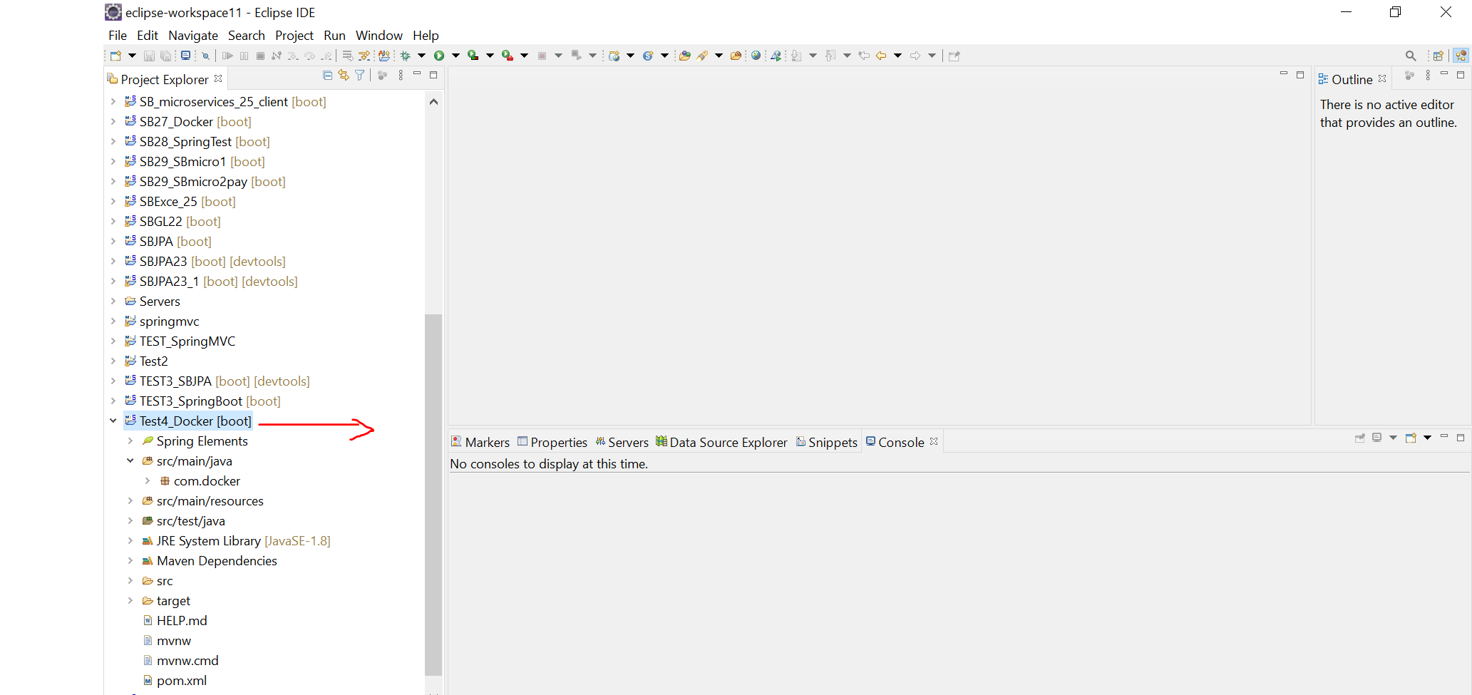

Step 2: add <finalName>Dock</finalName> in Pom.xml

Step 3 : create new file Name = Dockerfile in main project and add these

FROM openjdk:8

EXPOSE 8080

ADD target/dock.jar dock.jar

ENTRYPOINT [“java”,”-jar”,”dock.jar”]

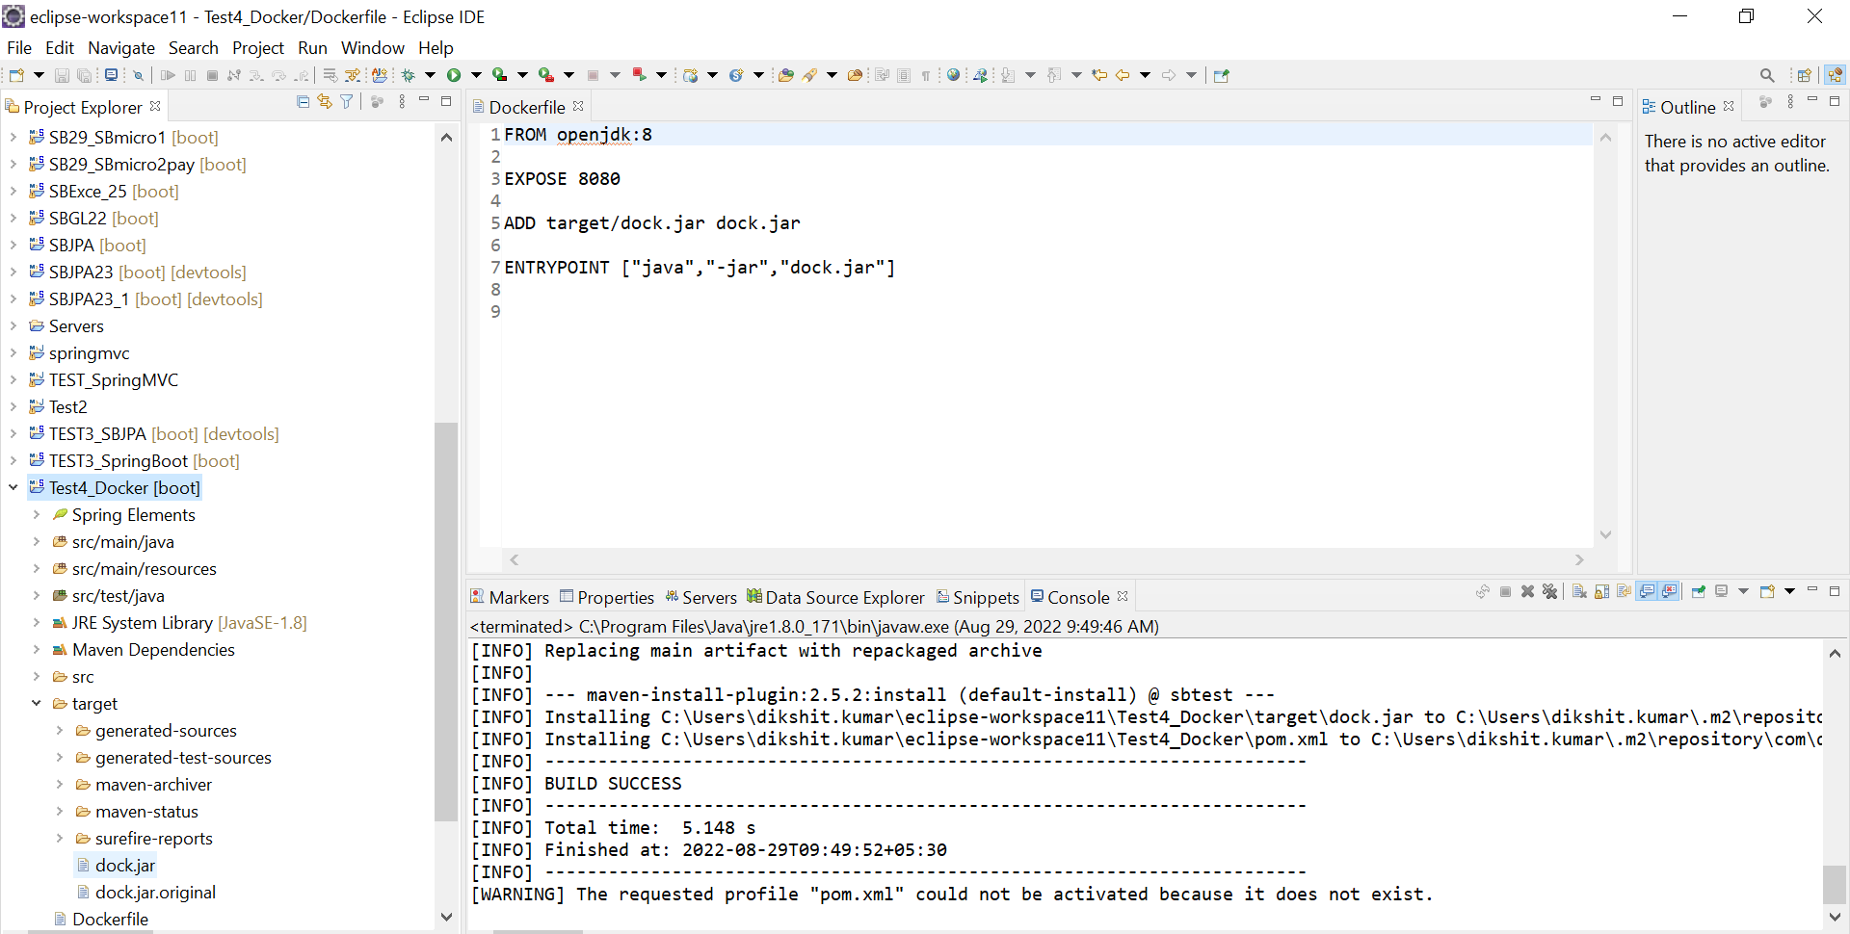

Step 4 : save all

Step 5: Run as Maven Install as show in picture

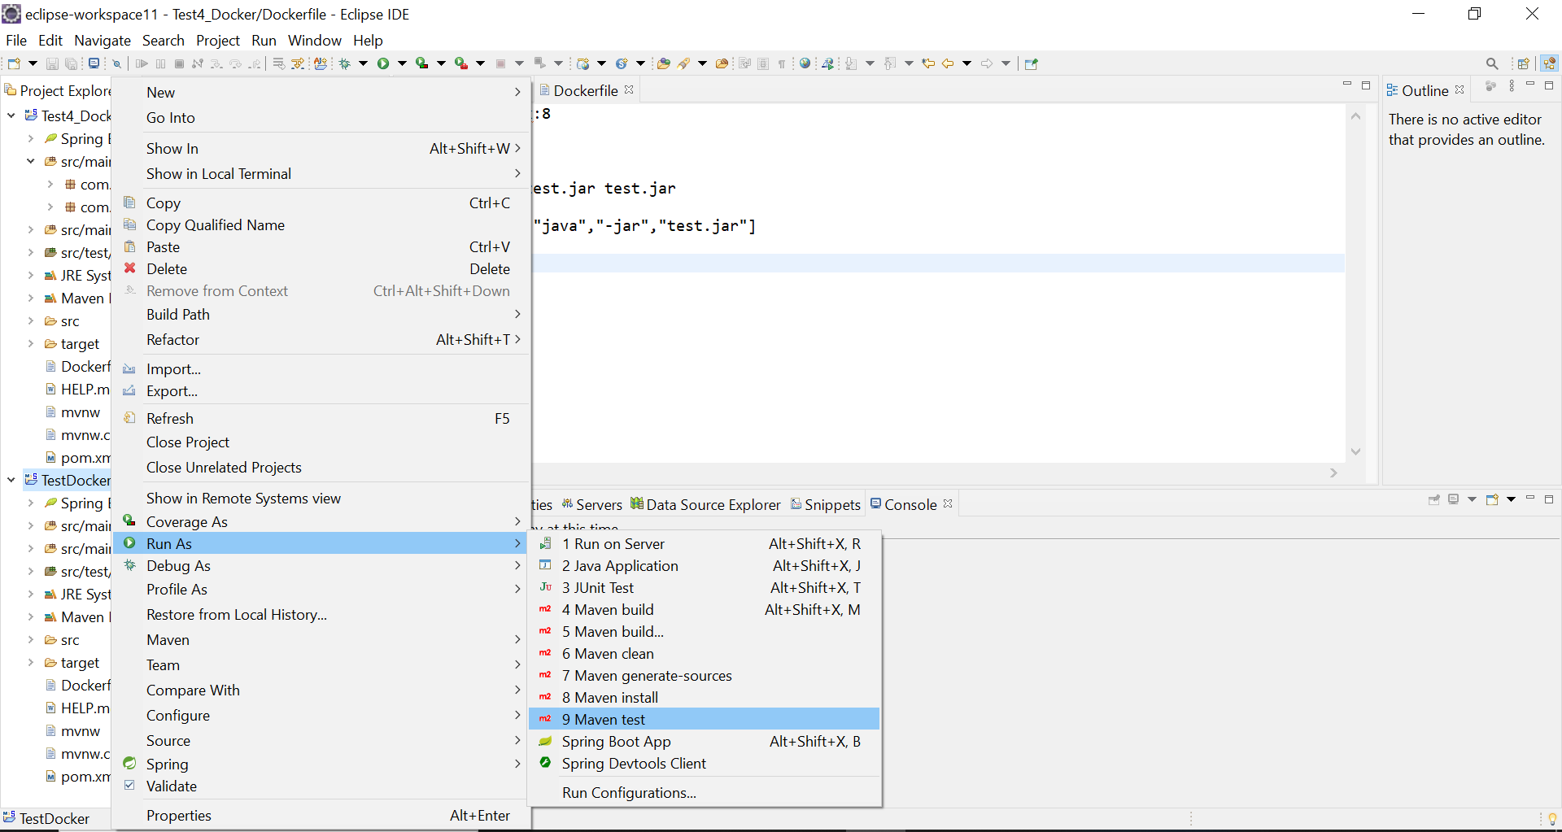

Then

Step 6:copy path address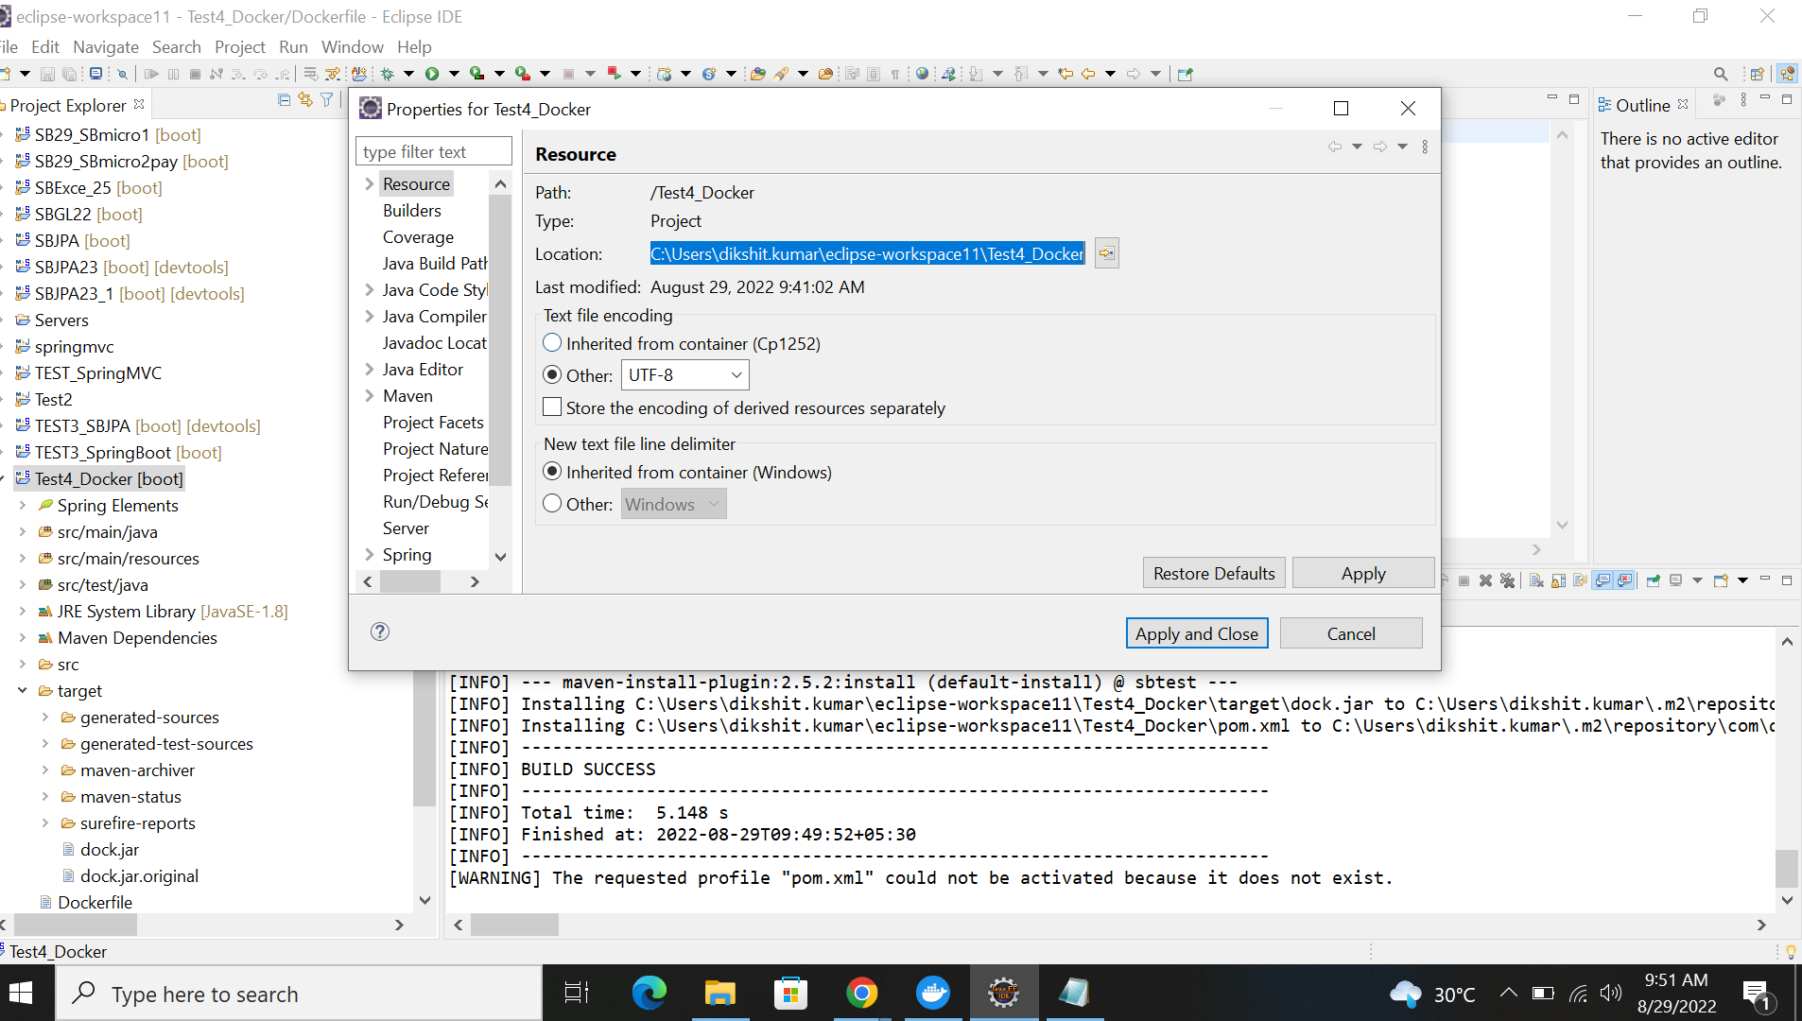

Step 7: Open Shell

ff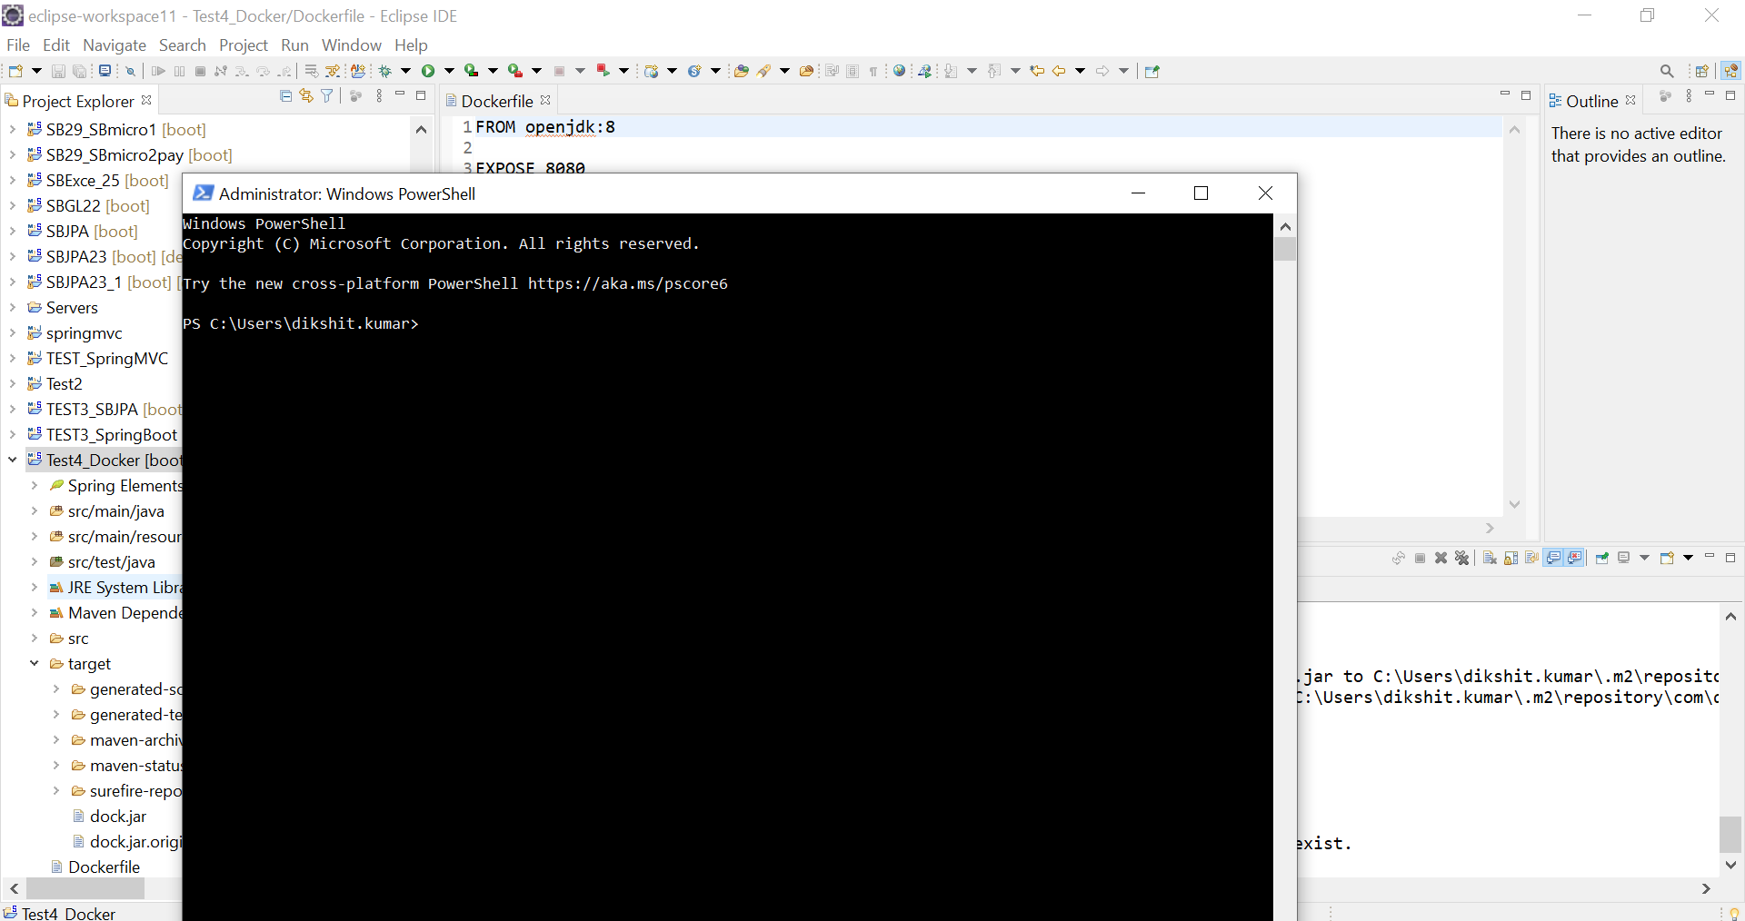

Step 8: cd paste copy path address 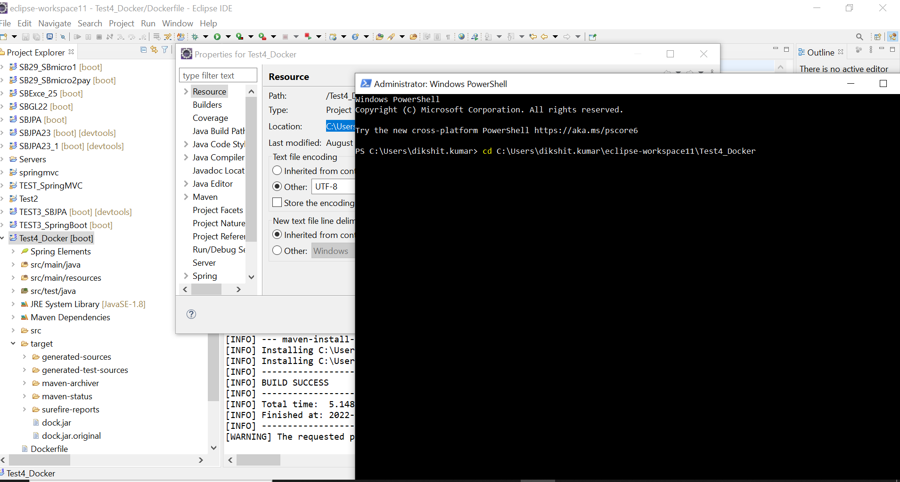

Step 9: now build image for docker “docker -t spring-boot-dock.jar”

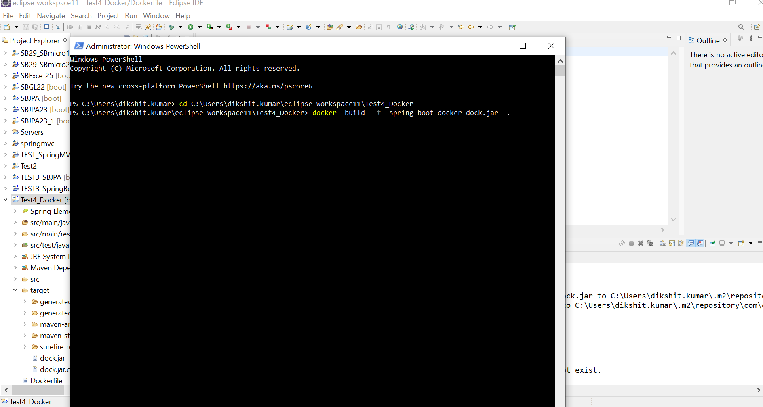

Step 10: After that type “run -p 9090:8080 spring-boot-docker-dock.jar” to run on server

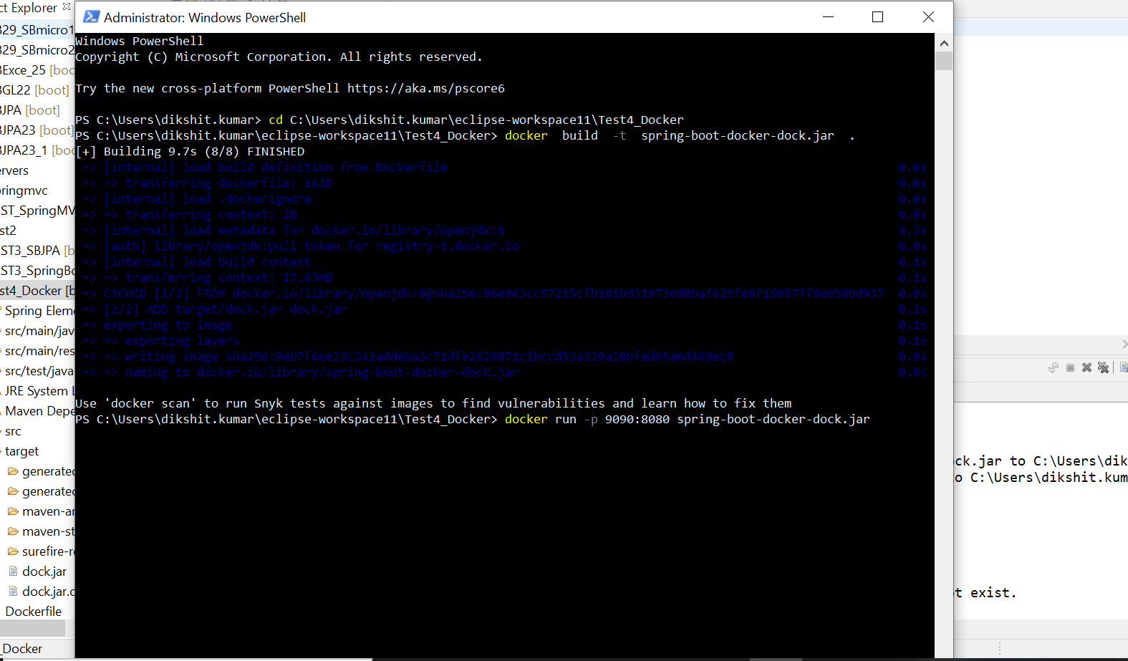

Step 11: now the server will start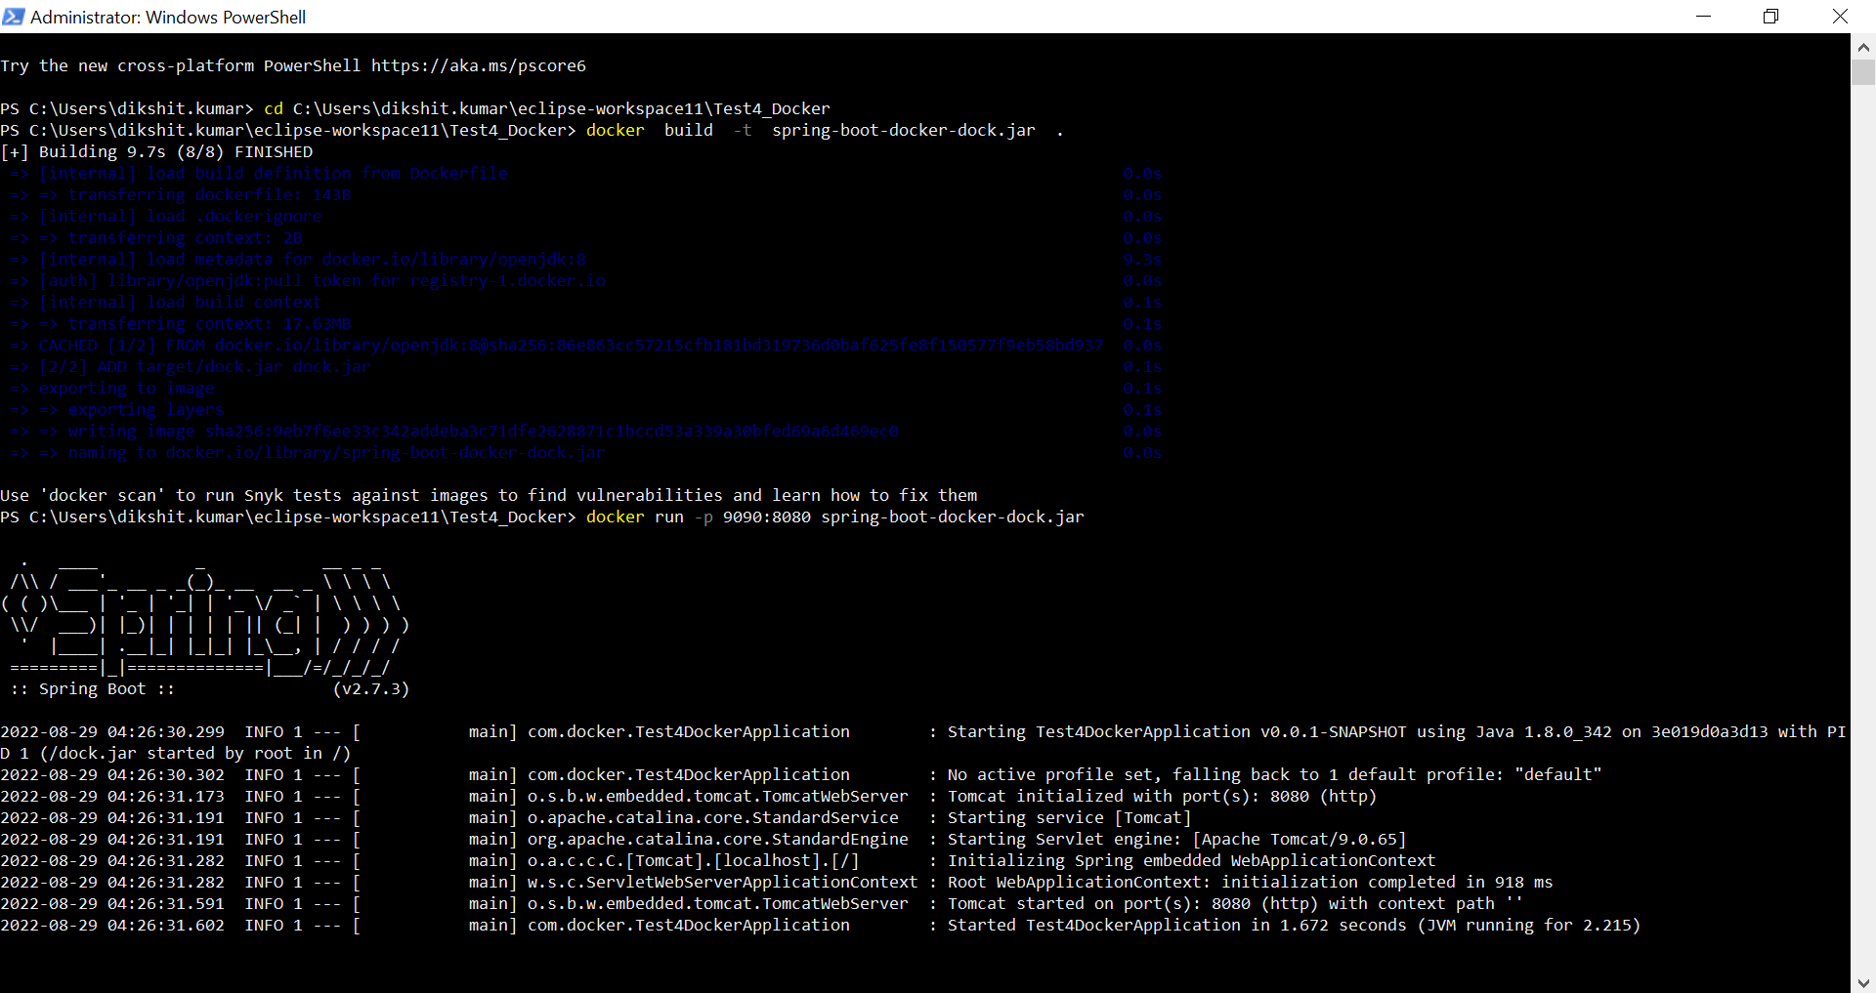

Step 12: now go on chrome and type <http://localhost:9090/doc>

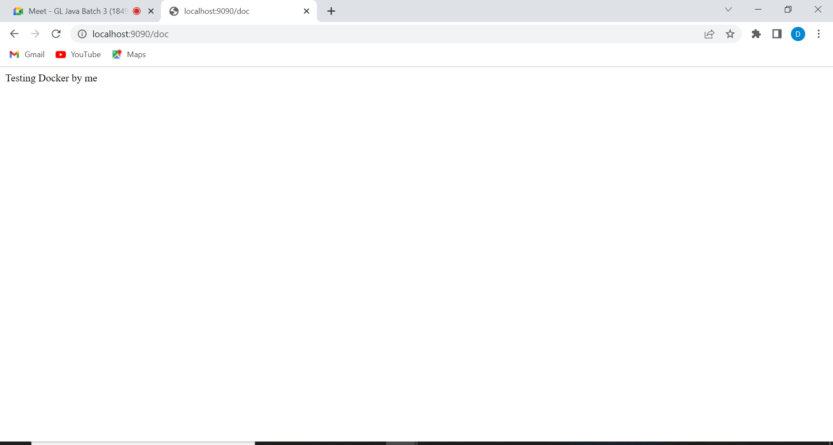

Step 13 : now login to docker as docker login

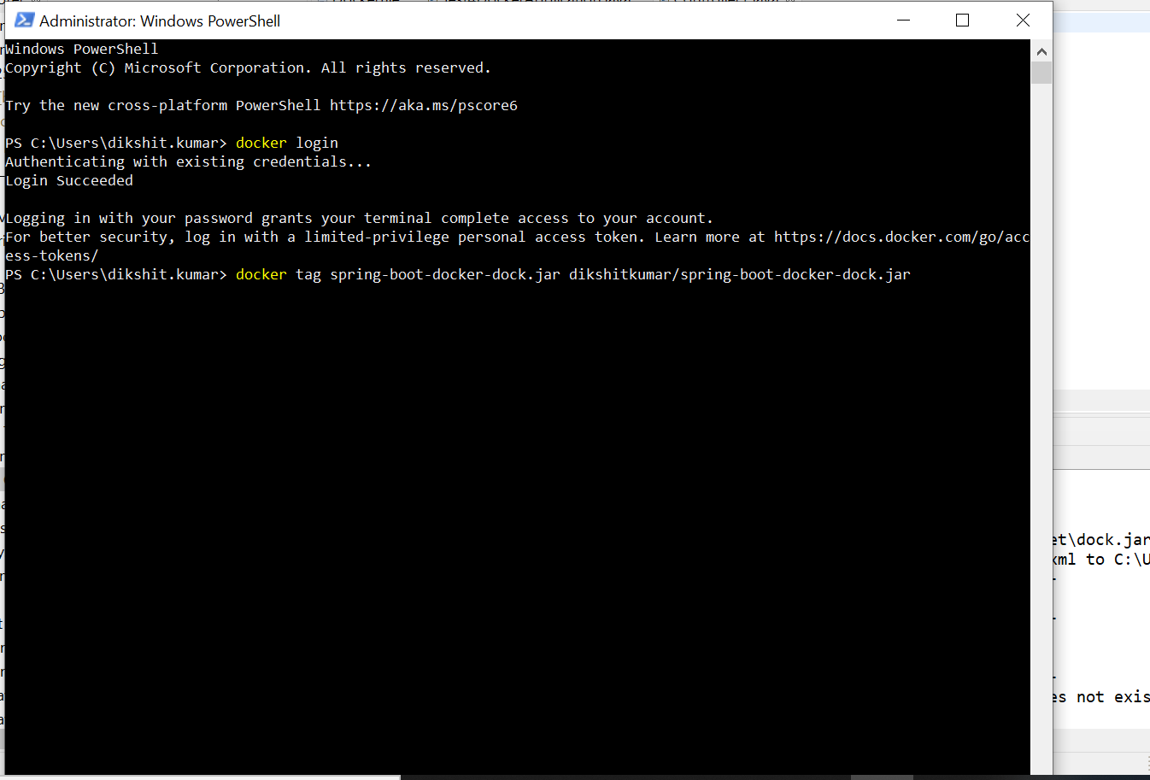

Step 13: now tag file to push details

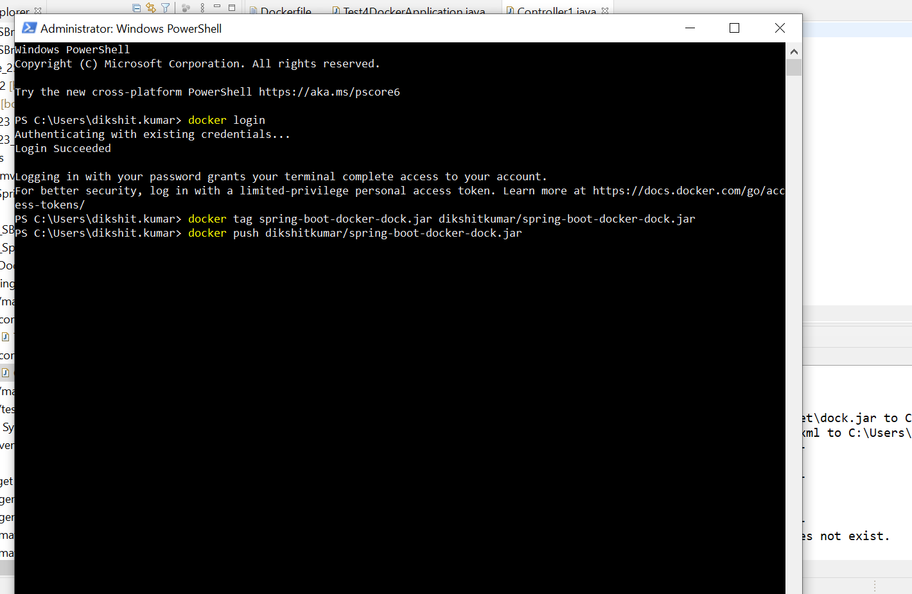

After pushing you will see in docker that its present there

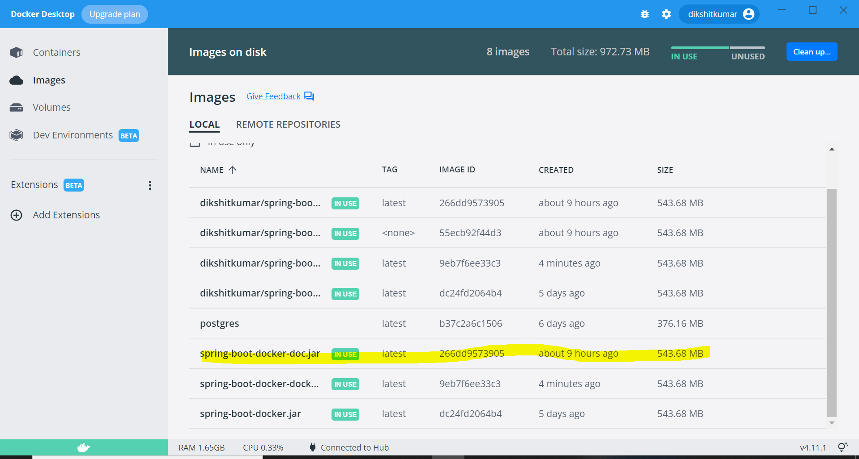

Step : for pulling

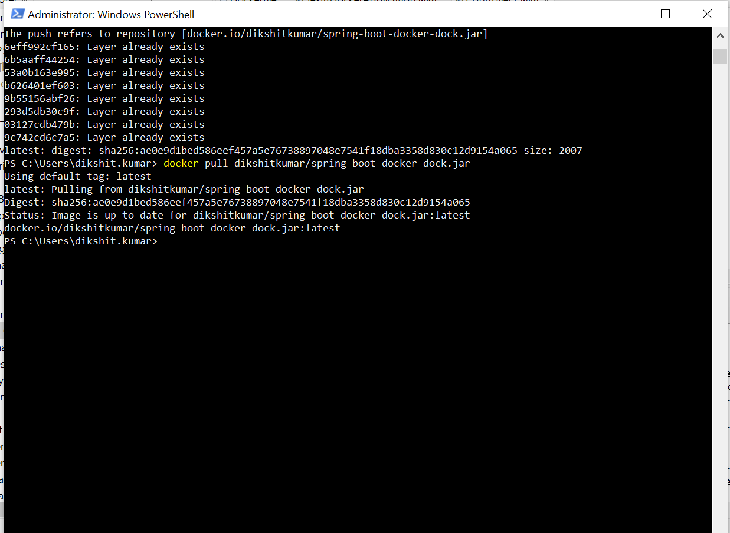 After that now you can start server form docker directly

